Sunday | Monday | Tuesday | Wednesday | Thursday | Friday | Saturday
 |  |  |  |  | 1  Student Choice!!  Choose any 3 exercises of your choice!! Challenge yourself and reach for 5 exercises!!  Repeat  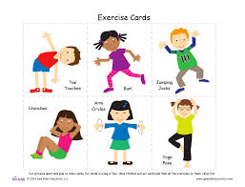 | 2  Stretching and Flexibility  Choose 5 stretches to complete.  Complete each stretch for 30-seconds.  Repeat  Click on Stretching and Flexibility document for examples.  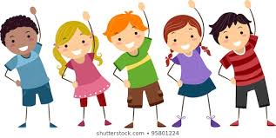
3  Outside  Get some fresh air. Take a walk, hike, play sports, ride your bike or play outside!  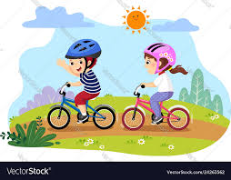 | 4  Leg Muscles  8 backward lunges  8 -12 calf raises  8 walking forward lunges  Repeat  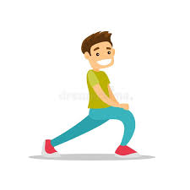 | 5  Core Muscles  8-12 crunches  15-30 second side plank  8-12 curl-ups  Repeat  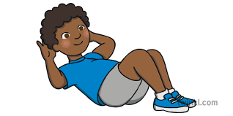 | 6  Cardio Day!  15-30 jumping jacks  30 second high knees  15 second Jump rope OR burpees  Repeat  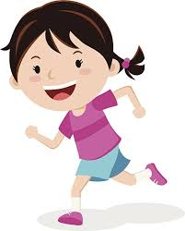 | 7  Upper Body Muscles  (Chest, Arms, Shoulders)  6-12 pushups  30 second arm circles  30 second shoulder shrugs  30 second neck roll  Repeat  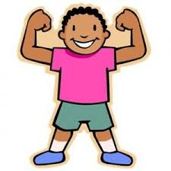 | 8  Student Choice!!  Choose any 3 exercises of your choice!! Challenge yourself and reach for 5 exercises!!  Repeat | 9  Stretching and Flexibility  Choose 5 stretches to complete.  Complete each stretch for 30-seconds.  Repeat  Click on Stretching and Flexibility document for examples  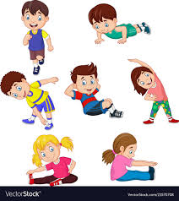
10  Outside  Get some fresh air. Take a walk, skip, run, ride your bike or play outside!  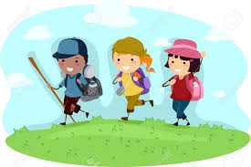 | 11  Leg Muscles  8 forward lunges  8 squats  8 squat jumps  Repeat  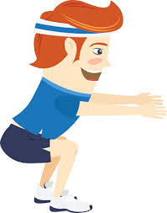 | 12  Core Muscles  8-12 crunches  15-30 second front plank  8-12 mountain climbers  Repeat  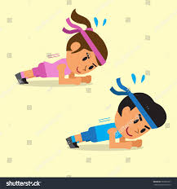 | 13  Cardio Day!  15-30 jumping jacks  30 second run in place  15 second Jump rope OR mountain climbers  Repeat  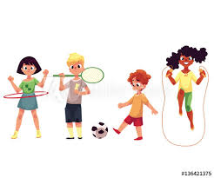 | 14  Upper Body Muscles  (Chest, Arms, Shoulders)  6-12 pushups  30 second arm circles  30 second shoulder shrugs  30 second neck roll  Repeat  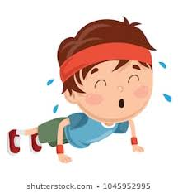 | 15  Student Choice!!  Choose any 3 exercises of your choice!! Challenge yourself and reach for 5 exercises!!  Repeat | 16  Stretching and Flexibility  Choose 5 stretches to complete.  Complete each stretch for 30-seconds.  Repeat  Click on Stretching and Flexibility document for examples
17  Outside  Get some fresh air. Take a walk, skip, run, ride your bike or play outside!  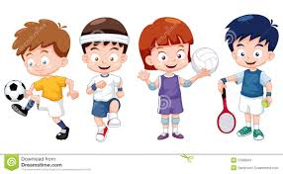 | 18  Leg Muscles  8 backward lunges  8 -12 calf raises  8 walking forward lunges  Repeat | 19  Core Muscles  8-12 crunches  15-30 second side plank  8-12 curl-ups  Repeat | 20  Cardio Day!  15-30 jumping jacks  30 second high knees  15 second Jump rope OR burpees  Repeat | 21  Upper Body Muscles  (Chest, Arms, Shoulders)  6-12 pushups  30 second arm circles  30 second shoulder shrugs  30 second neck roll  Repeat | 22  Student Choice!!  Choose any 3 exercises of your choice!! Challenge yourself and reach for 5 exercises!!  Repeat | 23  Stretching and Flexibility  Choose 5 stretches to complete.  Complete each stretch for 30-seconds.  Repeat  Click on Stretching and Flexibility document for examples
24  Outside  Get some fresh air. Take a walk, skip, run, ride your bike or play outside! | 25  Leg Muscles  8 forward lunges  8 squats  8 squat jumps  Repeat | 26  Core Muscles  8-12 crunches  15-30 second front plank  8-12 mountain climbers  Repeat | 27  Cardio Day!  15-30 jumping jacks  30 second run in place  15 second Jump rope OR mountain climbers  Repeat | 28  Upper Body Muscles  (Chest, Arms, Shoulders)  6-12 pushups  30 second arm circles  30 second shoulder shrugs  30 second neck roll  Repeat | 29  Student Choice!!  Choose any 3 exercises of your choice!! Challenge yourself and reach for 5 exercises!!  Repeat | 30  Stretching and Flexibility  Choose 5 stretches to complete.  Complete each stretch for 30-seconds.  Repeat  Click on Stretching and Flexibility document for examples
31
Outside
Get some fresh air. Take a walk, skip, run, ride your bike or play outside!

